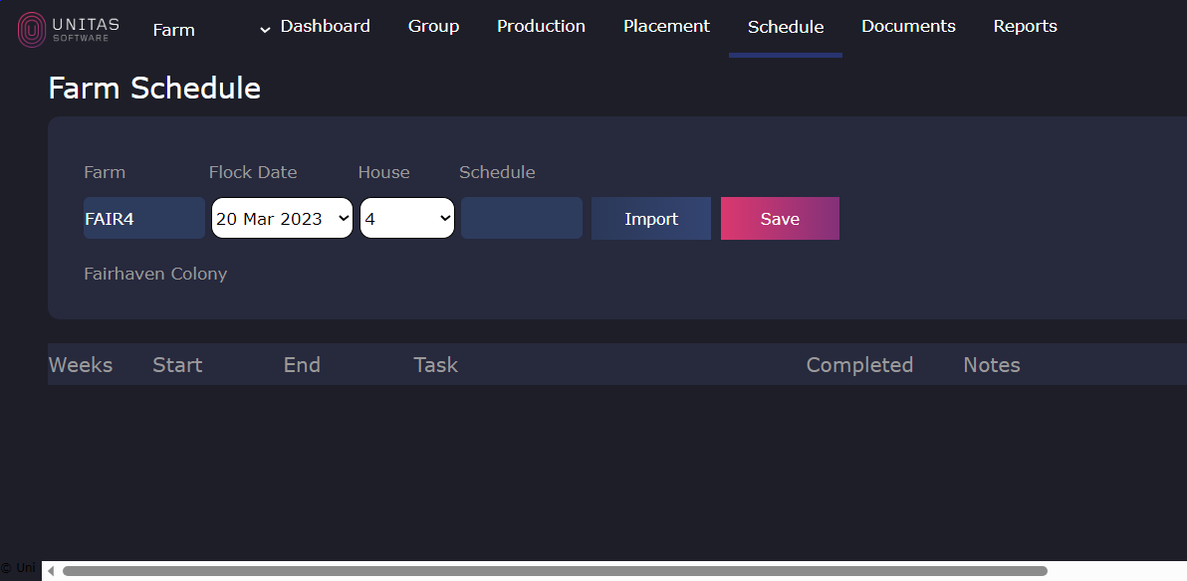

**FAIL: Image difference percentage 0.31074770736058727**